How to use NFS of Camera
System: ubuntu-16.04

(Note: If the system is installed in a virtual machine, please change the network adapter to bridging mode)
一、Installing NFS Server
1、Open the terminal, as shown in the following figure:
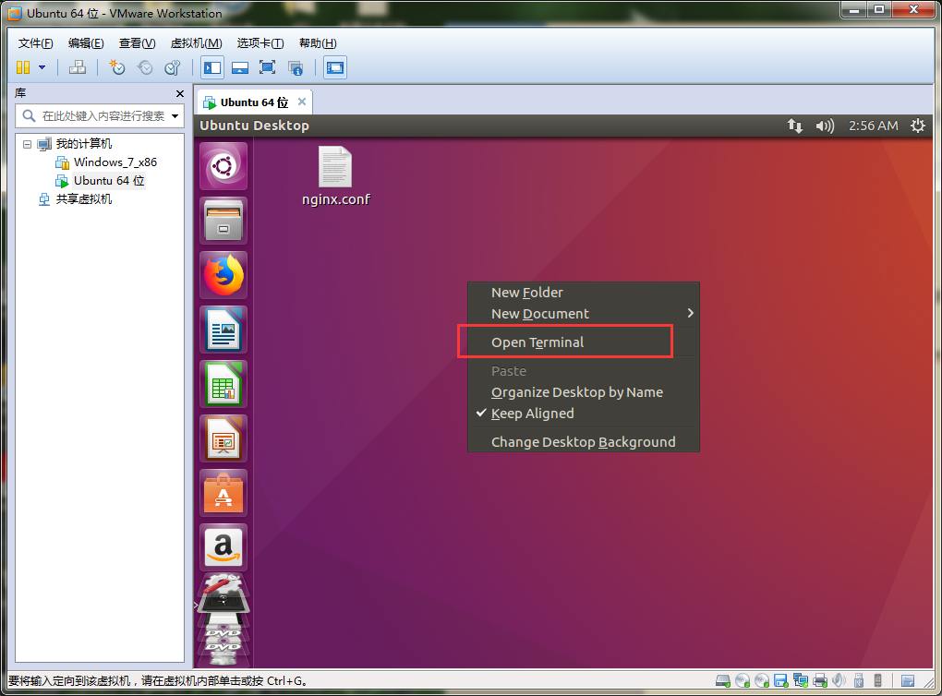
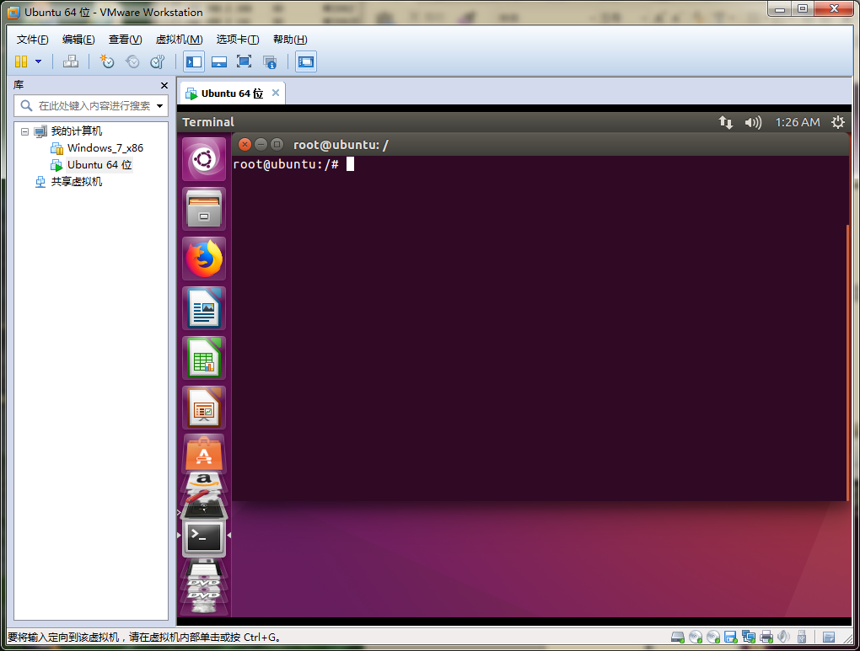
2. Enter the following command to install the NFS service, as shown in the following figure:
sudo apt-get install nfs-kernel-server
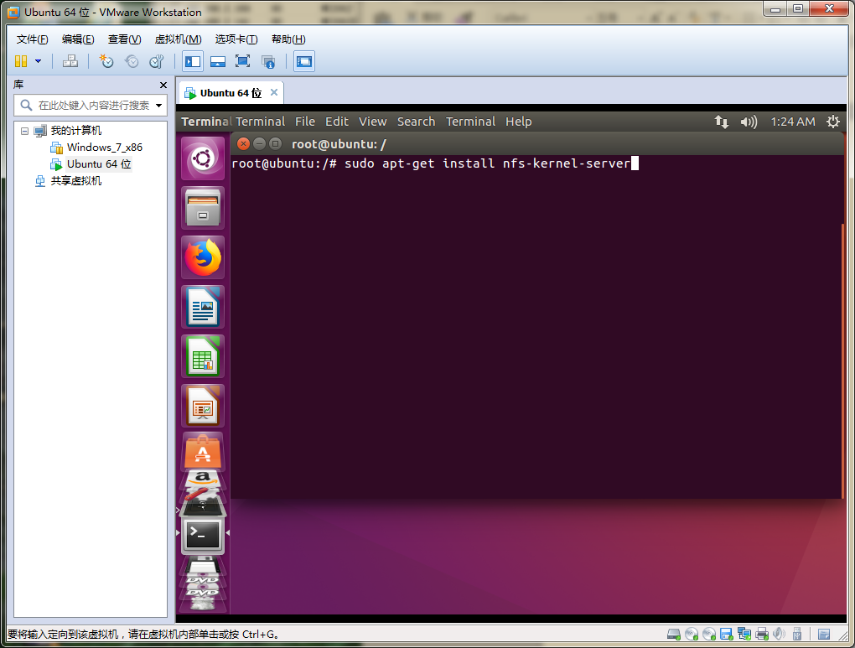
- Modifying Configuration Files
- 1. Enter the following command to enter the configuration file, as shown in the following figure:
sudo vi /etc/exports
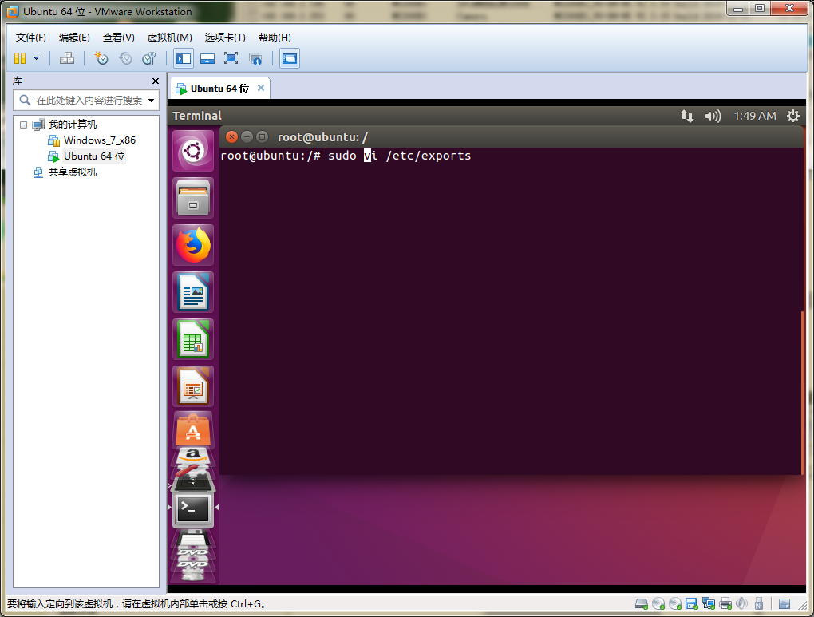
- Add the following content to the file and save it, as shown in the following figure：
/home/nfslife *(subtree check,rw,no_root_squash,async)
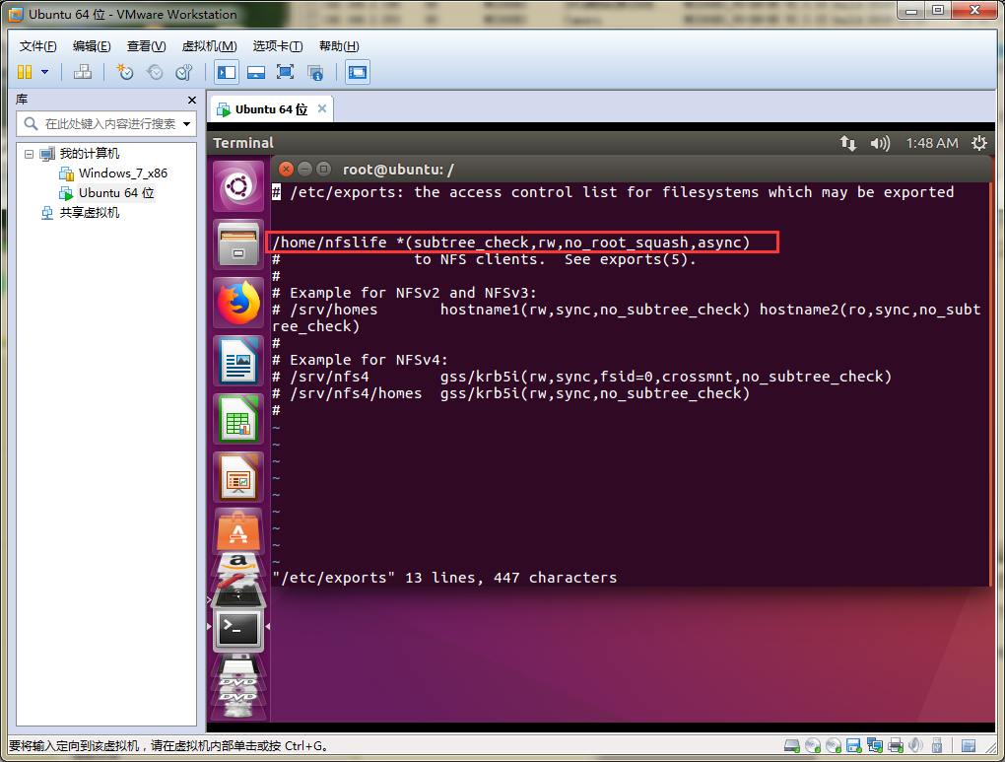
（Note: "/home/nfslife" This path can be modified according to the actual situation, but ensure that the directory already exists）
- Restart the server
Enter the following commands in sequence, as shown in the following figure:
sudo /etc/init.d/rpcbind restart
sudo /etc/init.d/nfs-kernel-server restart
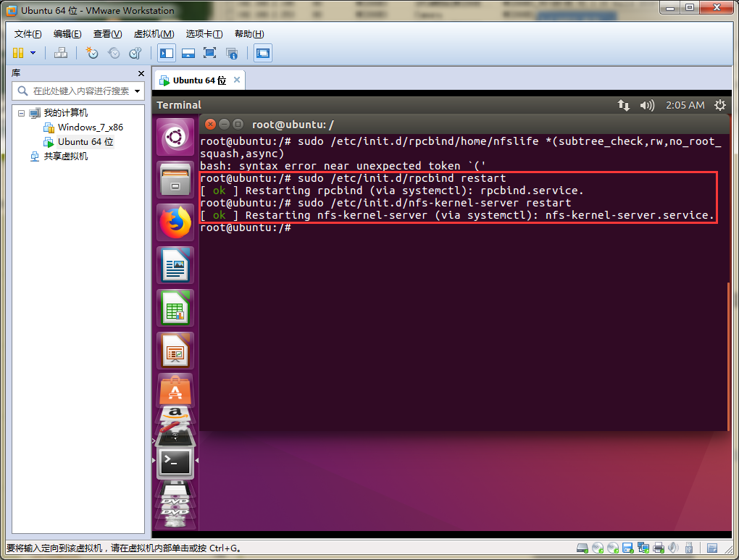
At this point, the NFS server is set up。

四、View NFS Mount Directory
Enter the following command, as shown in the following figure：
showmount -e HOST IP
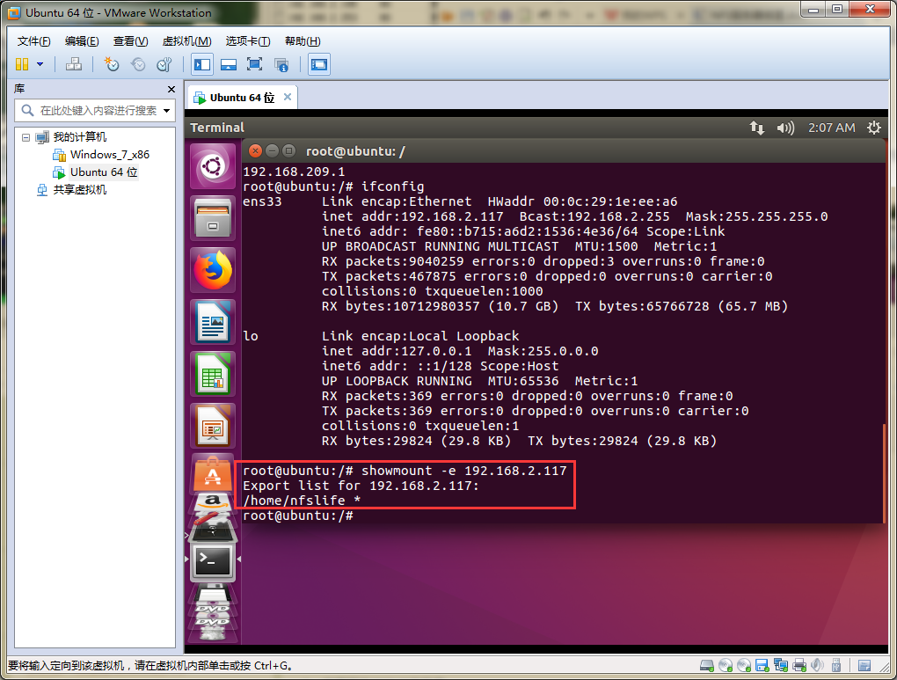
五、Configure IPC parameters as shown in the following figure;
